EX NO: 8 | Real-time monitoring of traffic in Youtube data streaming using Wireshark
DATE:22/08/26

Objectives
- To capture YouTube streaming traffic using Wireshark and identify the data packets associated with video transmission.
- To estimate the maximum bitrate of a YouTube video stream using the captured traffic statistics and analyze bandwidth utilization.

Software Requirements
  - Wireshark
  - Web Browser (Google Chrome/Mozilla Firefox)
  - Internet Connection
  - YouTube Website

Theory
Bitrate is the amount of data transmitted per unit time during video streaming and is typically measured in bits per second (bps), kilobits per second (kbps), or megabits per second (Mbps). A higher video resolution generally requires a higher bitrate and consumes more network bandwidth.

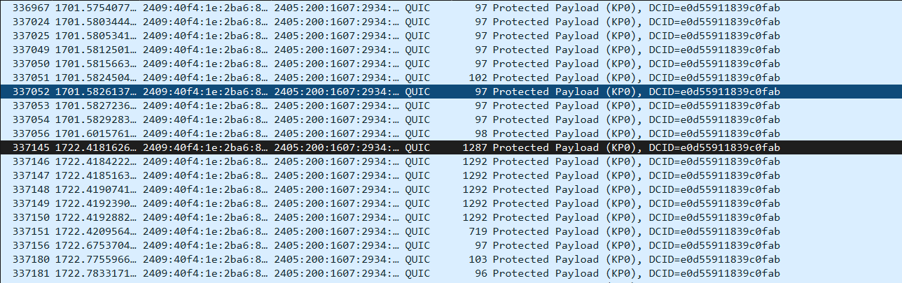

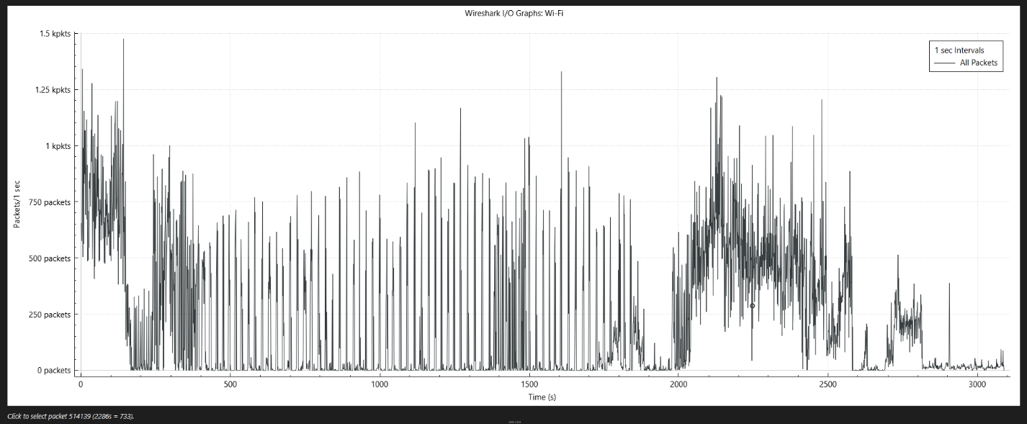

Procedure
Step 1: Open Wireshark and select the active network interface. Step 2: Click Start Capturing Packets.
Step 3: Open a web browser and navigate to: https://www.youtube.com
Step 4: Select a YouTube video and set the video quality to 720p (or any specified resolution). Step 5: Play the video continuously for approximately 60 seconds.
Step 6: Stop the packet capture after the streaming duration. Step 7: Apply the filter: tcp or tls to isolate streaming traffic.

Step 8: Navigate to: Statistics → Conversations or Statistics → Endpoints and determine the total amount of data transferred during the streaming session.
Step 9 Record: Total Data Transferred (Bytes), Streaming Duration (Seconds) Step 10: Calculate the average bitrate using:

Resolution | Time frame | Maximum data rate (bits/sec) | Average data rate
1920x1080 | 1s | 12.5 Mb/s | 10.6 Mb/s
 | 3s | 8.9 Mb/s
 | 10s | 14 Mb/s
 | 200ms | 7 Mb/s
1280 × 720 | 200ms | 14.7 Mb/s | 10.47 Mb/s
 | 500ms | 12 Mb/s
 | 1s | 10 Mb/s
 | 10s | 6 Mb/s

Result 1
The YouTube streaming traffic was successfully captured using Wireshark. The total amount of data transferred during the video playback session was identified from the captured packets, enabling analysis of the network resources utilized by the streaming application.

Result 2
The average bitrate of the YouTube video stream was successfully estimated using the captured traffic statistics and streaming duration. The results demonstrated the relationship between video quality, data transfer rate, and bandwidth consumption during video streaming.

Test Case Question 1
Implement the specified setup and estimate the maximum bitrate of a YouTube video stream at a low resolution using Wireshark.

Case 1
  - Number of PCs: 1
  - Internet Connection: Available
  - Packet Analyzer: Wireshark
  - Streaming Application: YouTube
  - Video Resolution: 192 × 144
  - Streaming Duration: 60 Seconds

Tasks
- Capture YouTube streaming traffic using Wireshark while playing a video at 192 × 144 resolution for 60 seconds.
- Identify the streaming packets and determine the total amount of data transferred using Wireshark statistics.
- Calculate the maximum and average bitrate of the video stream and analyze the bandwidth utilization.

Test Case Question 2
Implement the specified setup and estimate the maximum bitrate of a YouTube video stream at a high resolution using Wireshark.

Case 2
  - Number of PCs: 1
  - Internet Connection: Available
  - Packet Analyzer: Wireshark
  - Streaming Application: YouTube
  - Video Resolution: 1280 × 720 (720p)
  - Streaming Duration: 60 Seconds

Tasks
- Capture YouTube streaming traffic using Wireshark while playing a video at 1280 × 720 resolution for 60 seconds.

- Identify the streaming packets and determine the total amount of data transferred using Wireshark statistics.
- Calculate the maximum and average bitrate of the video stream and compare the bandwidth utilization with the lower-resolution stream.

